Set Up Centralized Logging

Overview

This document guides you through setting up a centralized logging system on Ubuntu using Docker, Grafana, Loki, and Promtail.
The system allows you to collect logs from multiple sources, store them in a centralized location (Loki), and visualize them in real-time through Grafana dashboards. Promtail acts as the log collector, shipping system and application logs to Loki. Grafana provides an intuitive interface for querying, exploring, and visualizing logs, enabling better monitoring, debugging, and observability of your applications and infrastructure.

Prerequisites

- Ubuntu OS
- Docker
- Grafana installed
- Basic knowledge of terminal commands in Linux.

Step 1: Install Loki and Promtail

- Open Ubuntu
- Create a directory called loki. Make loki your current working directory:
  - mkdir loki
  - cd loki

- Copy and paste the following commands into your command line to download loki-local-config.yaml to your loki directory:
  - wget https://raw.githubusercontent.com/grafana/loki/v3.4.1/cmd/loki/loki-local-config.yaml -O loki-config.yaml

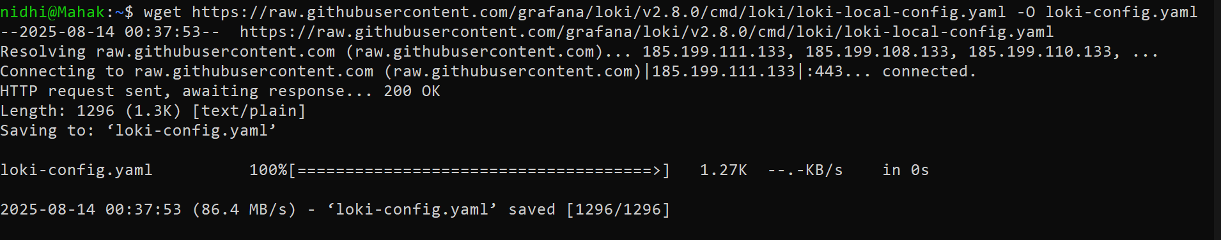

(This is the default Loki configuration for running a single-node setup. It defines how Loki will receive, store, and index logs.)
- Run the following command to download promtail-docker-config.yaml to your loki directory:
  - wget https://raw.githubusercontent.com/grafana/loki/v3.4.1/clients/cmd/promtail/promtail-docker-config.yaml -O promtail-config.yaml

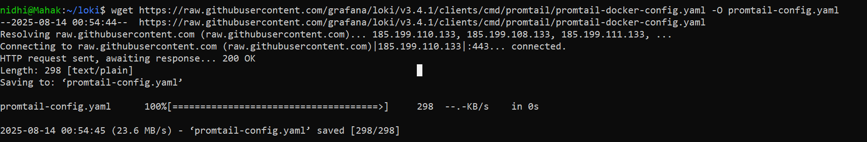
Promtail uses this configuration to know which log files to monitor (/var/log/*.log) and where to send them (Loki).

- Run your docker in your laptop

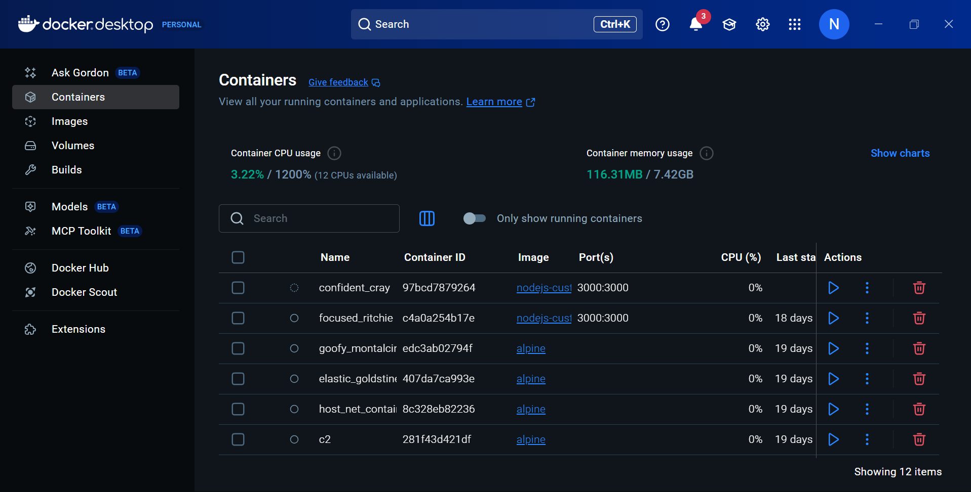

- Start the Docker containers using the configuration files you downloaded in the previous step for loki:
  - docker run --name loki -d -v $(pwd):/mnt/config -p 3100:3100 grafana/loki:3.4.1 -config.file=/mnt/config/loki-config.yaml

Explanation:
- -v $(pwd):/mnt/config mounts the current directory inside the container.
- -p 3100:3100 exposes Loki’s HTTP API port.
- Loki runs in the background as a daemon (-d).

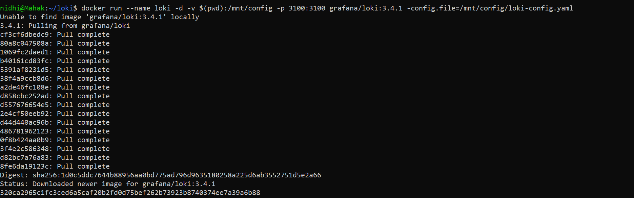

- For promtail:
  - docker run --name promtail -d -v $(pwd):/mnt/config -v /var/log:/var/log --link loki grafana/promtail:3.4.1 -config.file=/mnt/config/promtail-config.yaml
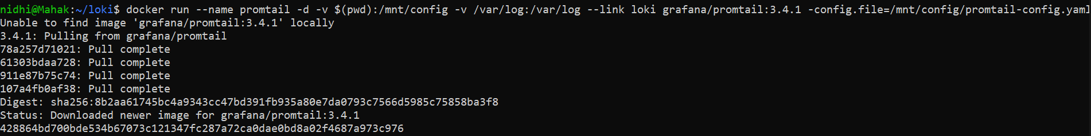

Explanation:
- -v /var/log:/var/log allows Promtail to read system logs from the host.
- --link loki connects Promtail to the Loki container.
- Promtail ships logs to Loki based on the configuration file.

- Verify that your containers are running:
  - docker container ls

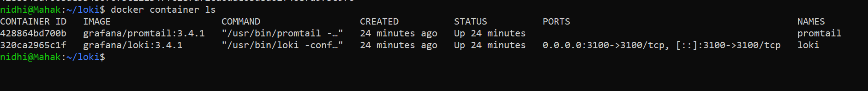

- Verify that Loki is up and running.
  - To view readiness, navigate to http://localhost:3100/ready

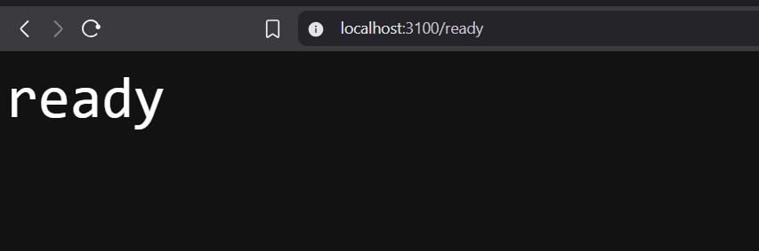
- To view metrics, navigate to http://localhost:3100/metrics

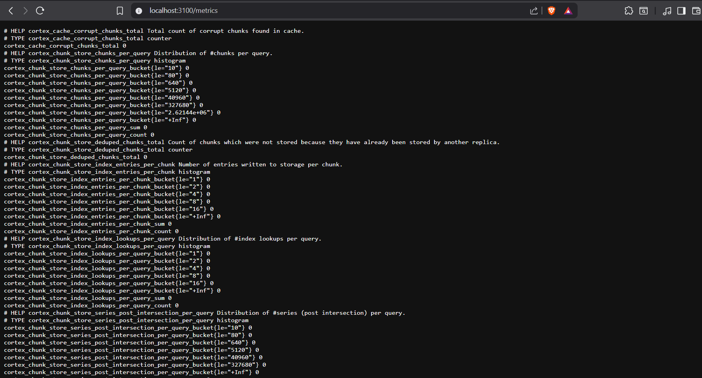

These endpoints confirm Loki is running and ready to receive logs.

Step 2: Run Grafana

- Start Grafana on terminal:
  - sudo systemctl start grafana-server

(Enter you ubuntu password)

- To verify Grafana is running:
  - sudo systemctl status grafana-server

(Grafana is used to query logs from Loki and visualize them in dashboards.) 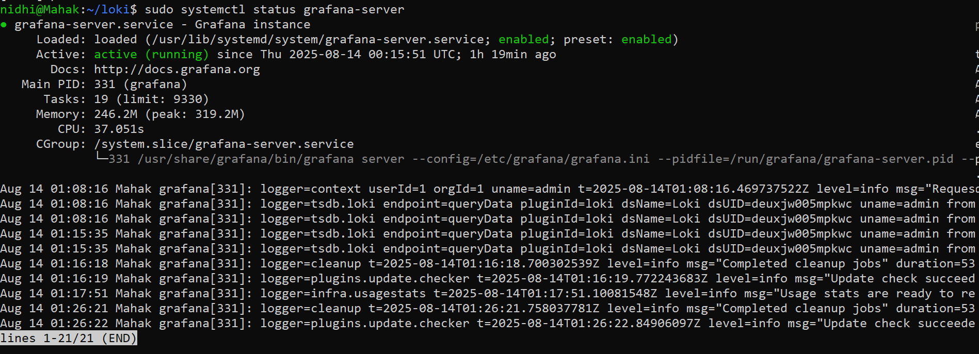

- If you want to view logs:
  - sudo journalctl -u grafana-server -f

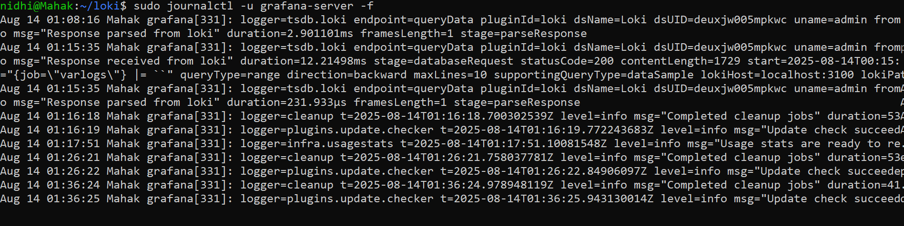

- Once started, Grafana will be available at:
  - http://localhost:3000

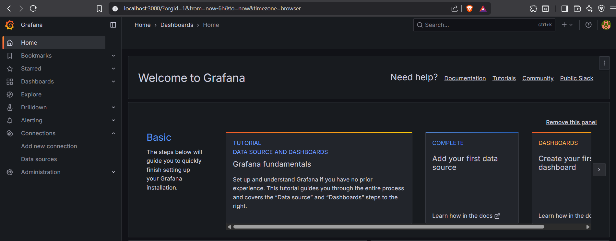

Step 3: Add Loki Data Source

- Navigate to Data Sources in Grafana’s configuration section.

- This is where you manage all external data integrations (e.g., Prometheus, Loki, Elasticsearch)

- Click "Add new data source"

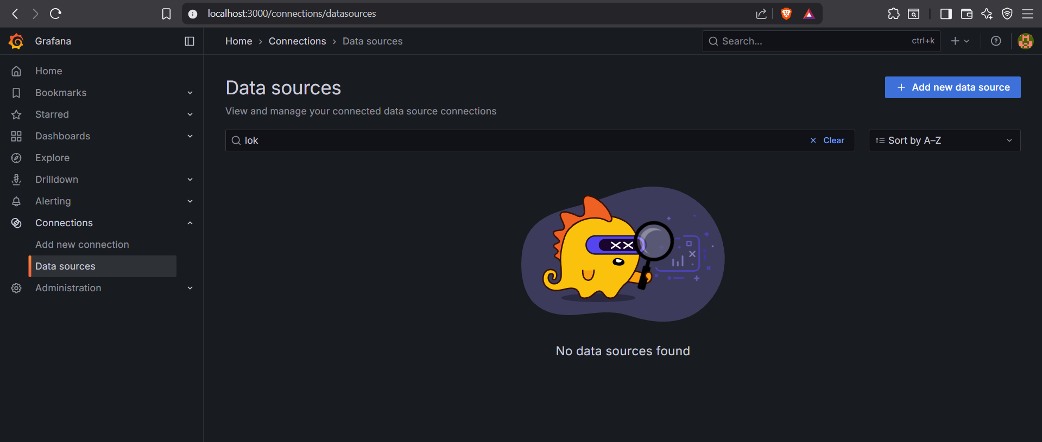

- Select Loki from the list

  - Loki is a horizontally scalable, highly available log aggregation system designed for efficiency

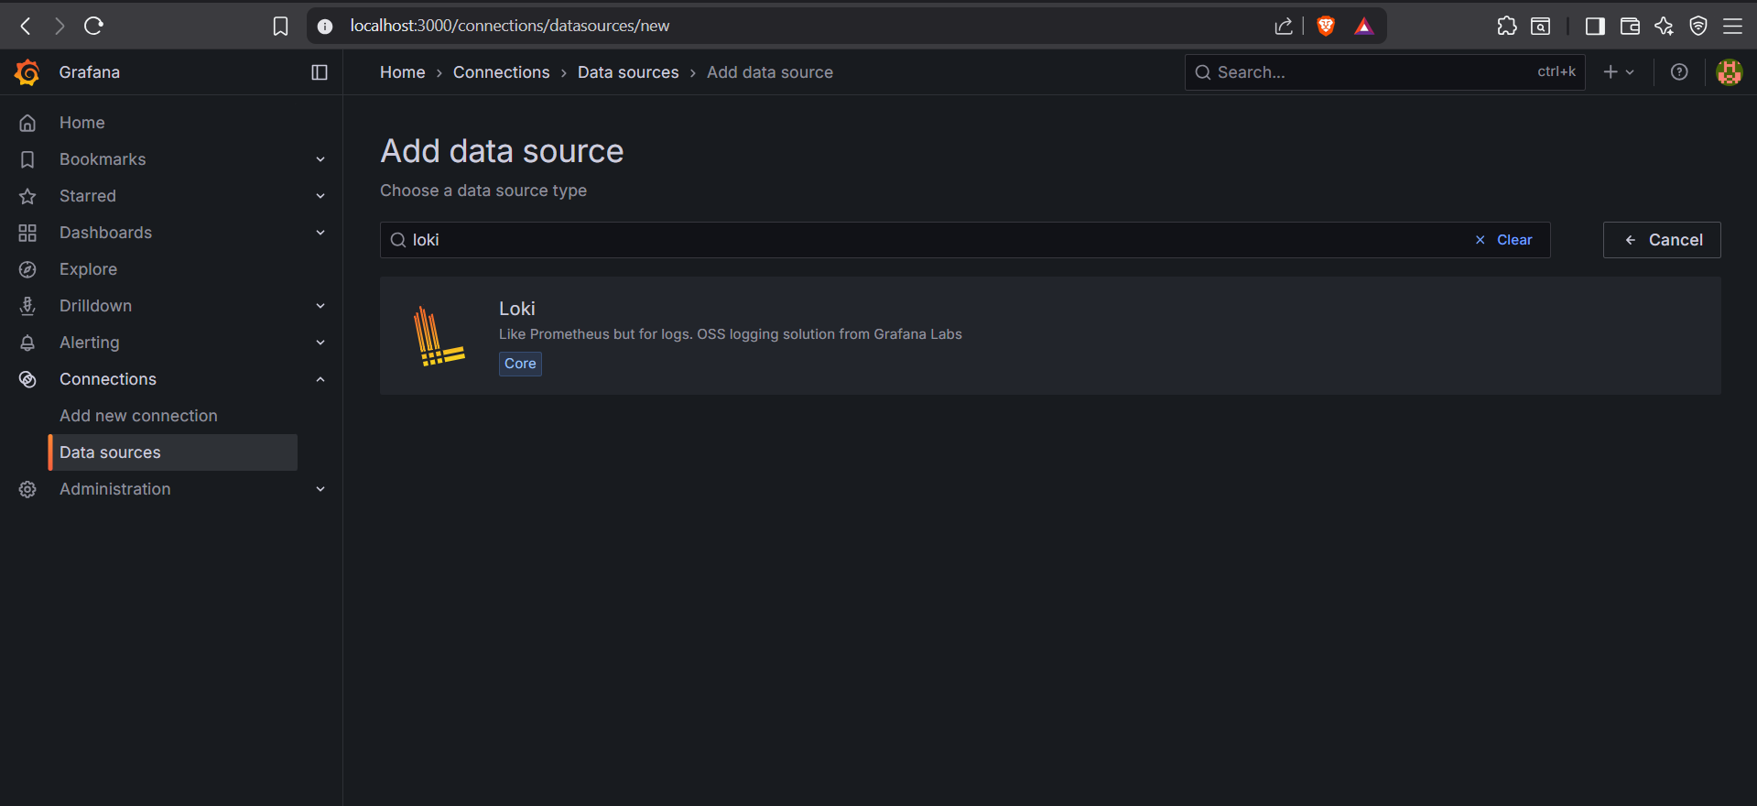

- Add the Loki URL: http://localhost:3100

- This is the default endpoint where Loki is running. Modify if Loki is hosted remotely
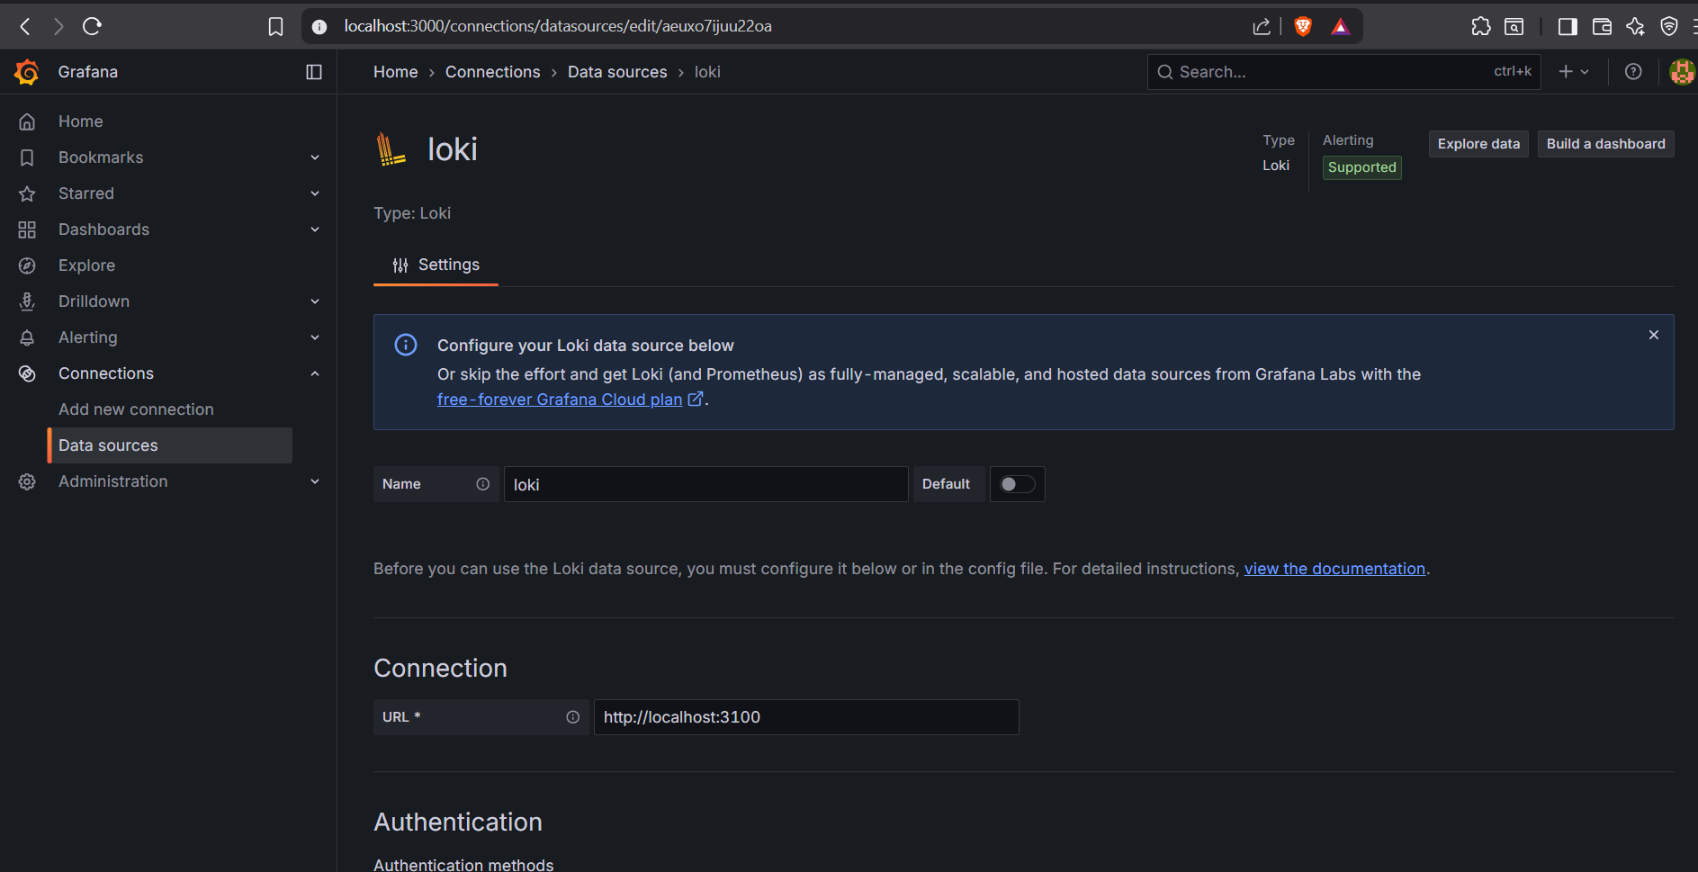

- Click Save & test.
- Navigate to Explore (right sidebar) to query logs interactively

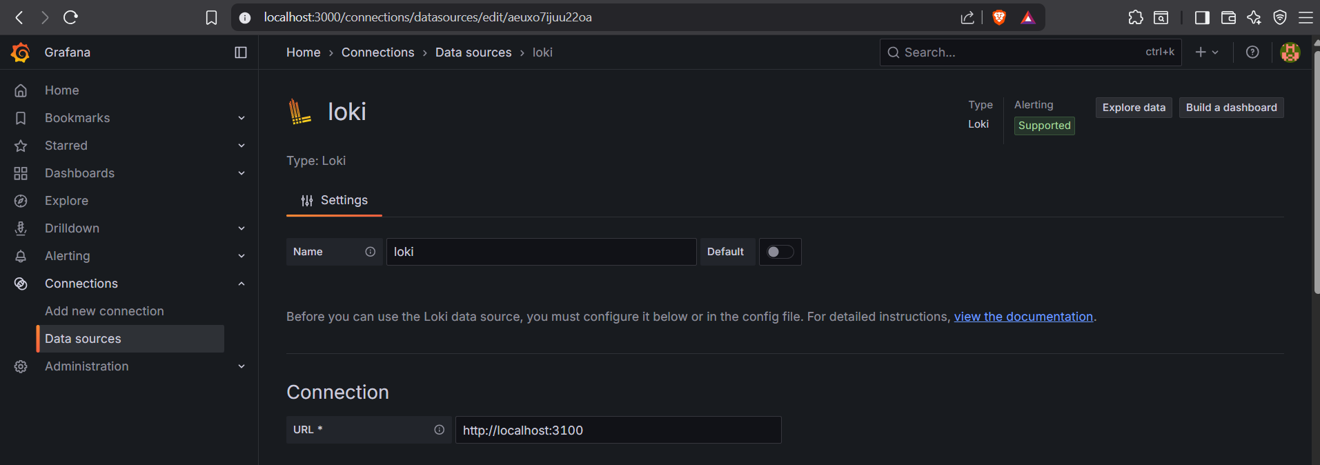

- Select Loki as the data source

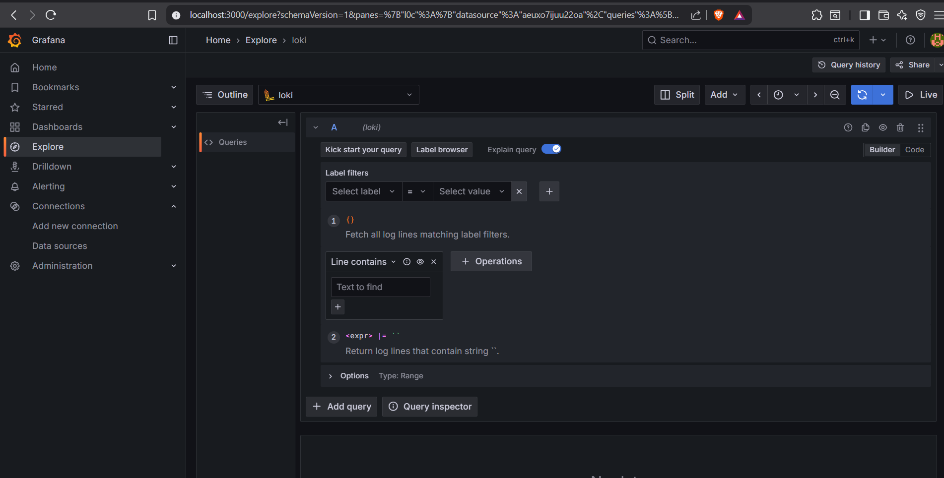

- Under Label filters, select:
  - Label: job

- Labels in Loki help filter logs efficiently (similar to Prometheus)

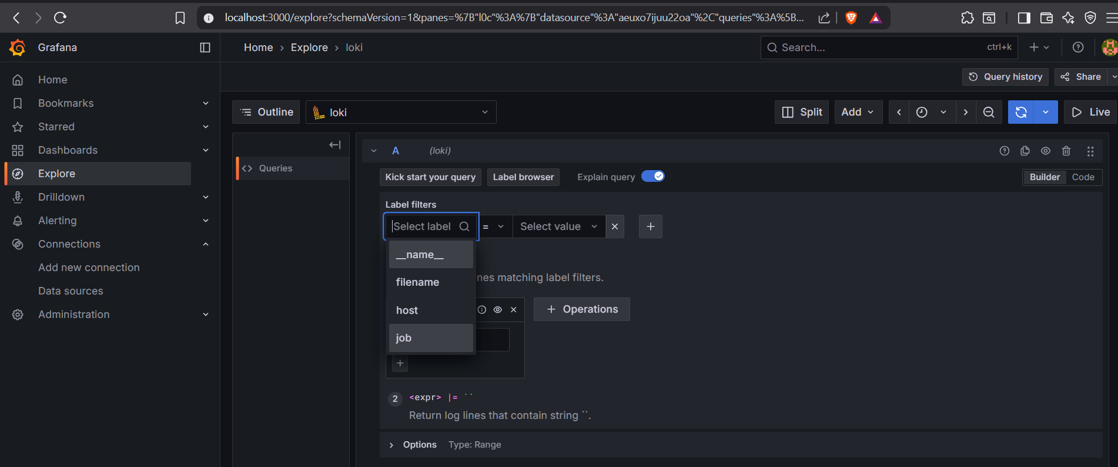

- Value: varlogs

- This restricts logs to those tagged with job="varlogs" (typically system logs)

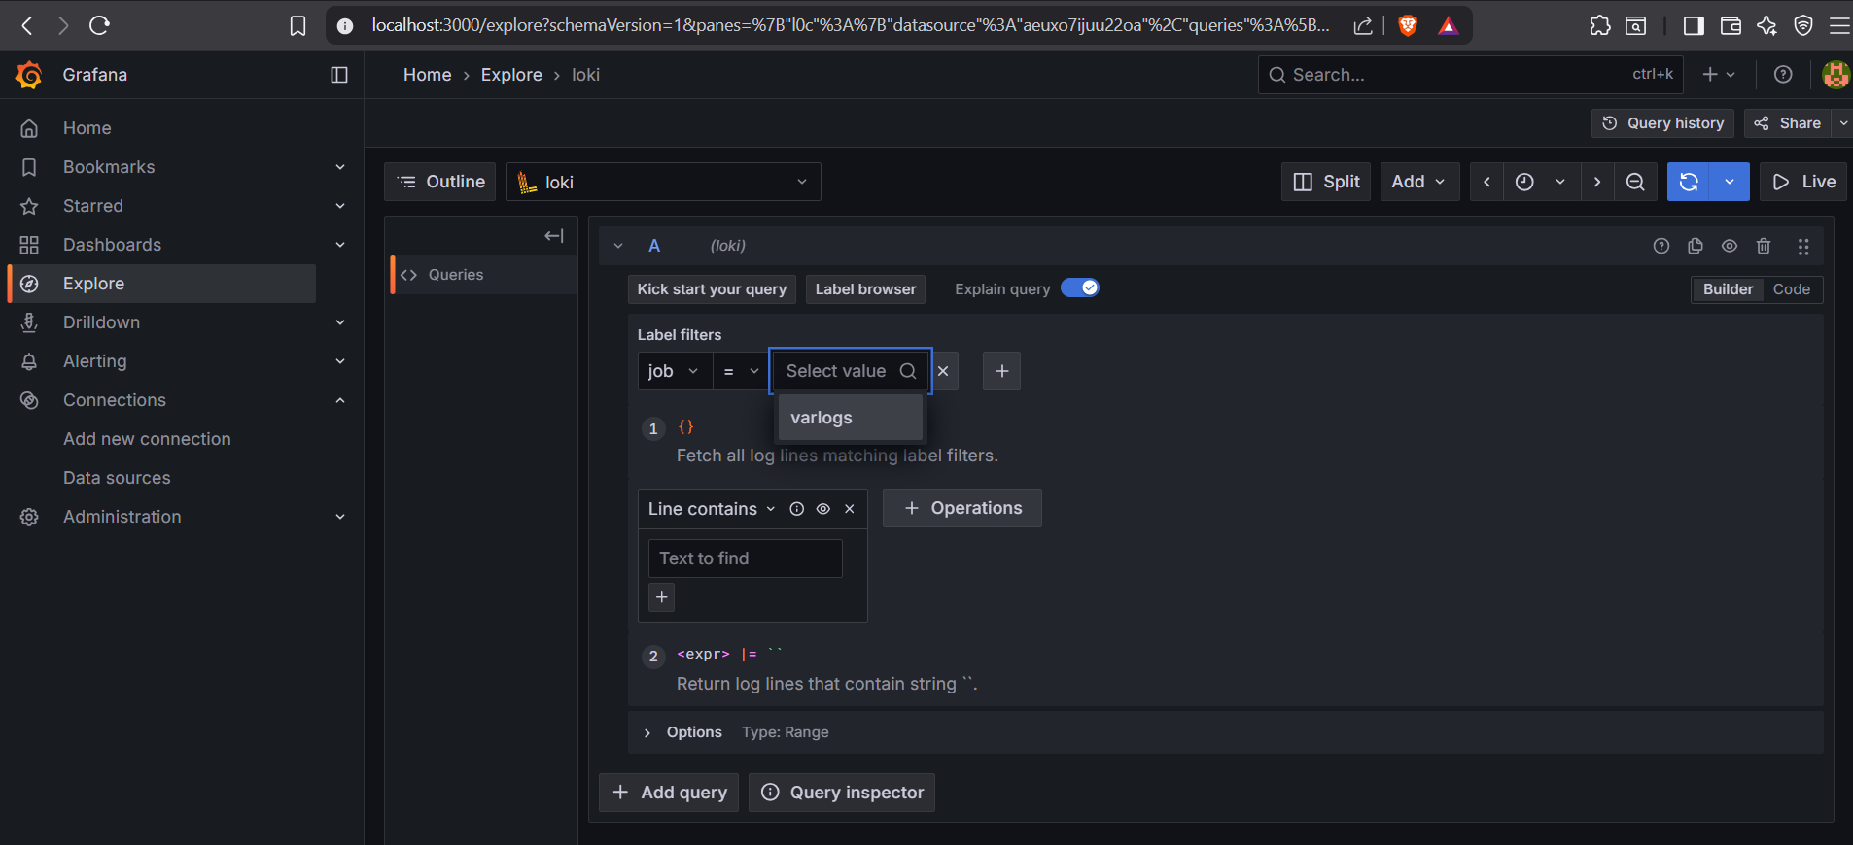

- Run the query

- Logs matching the filter will appear in raw or structured format
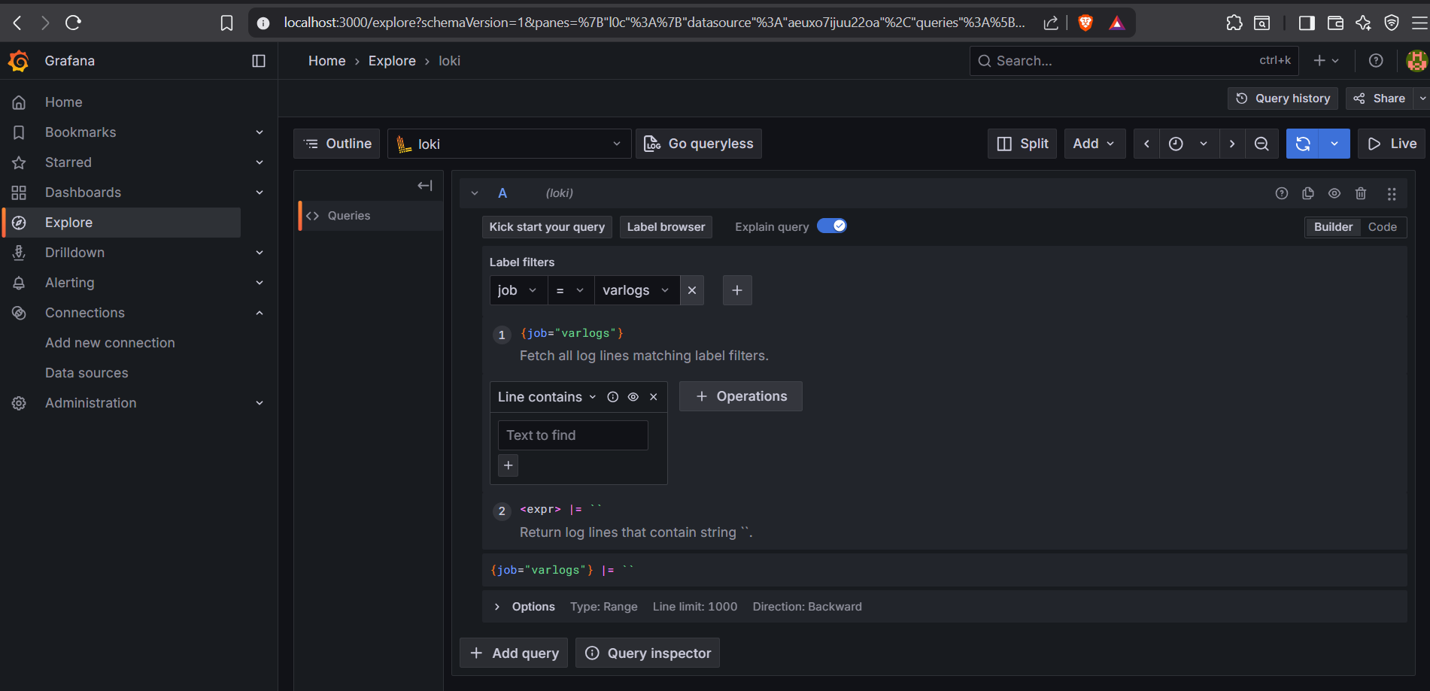

- Check the returned logs to ensure Loki is correctly ingesting and exposing log data

- If no logs appear, verify Loki’s configuration and log scraping settings

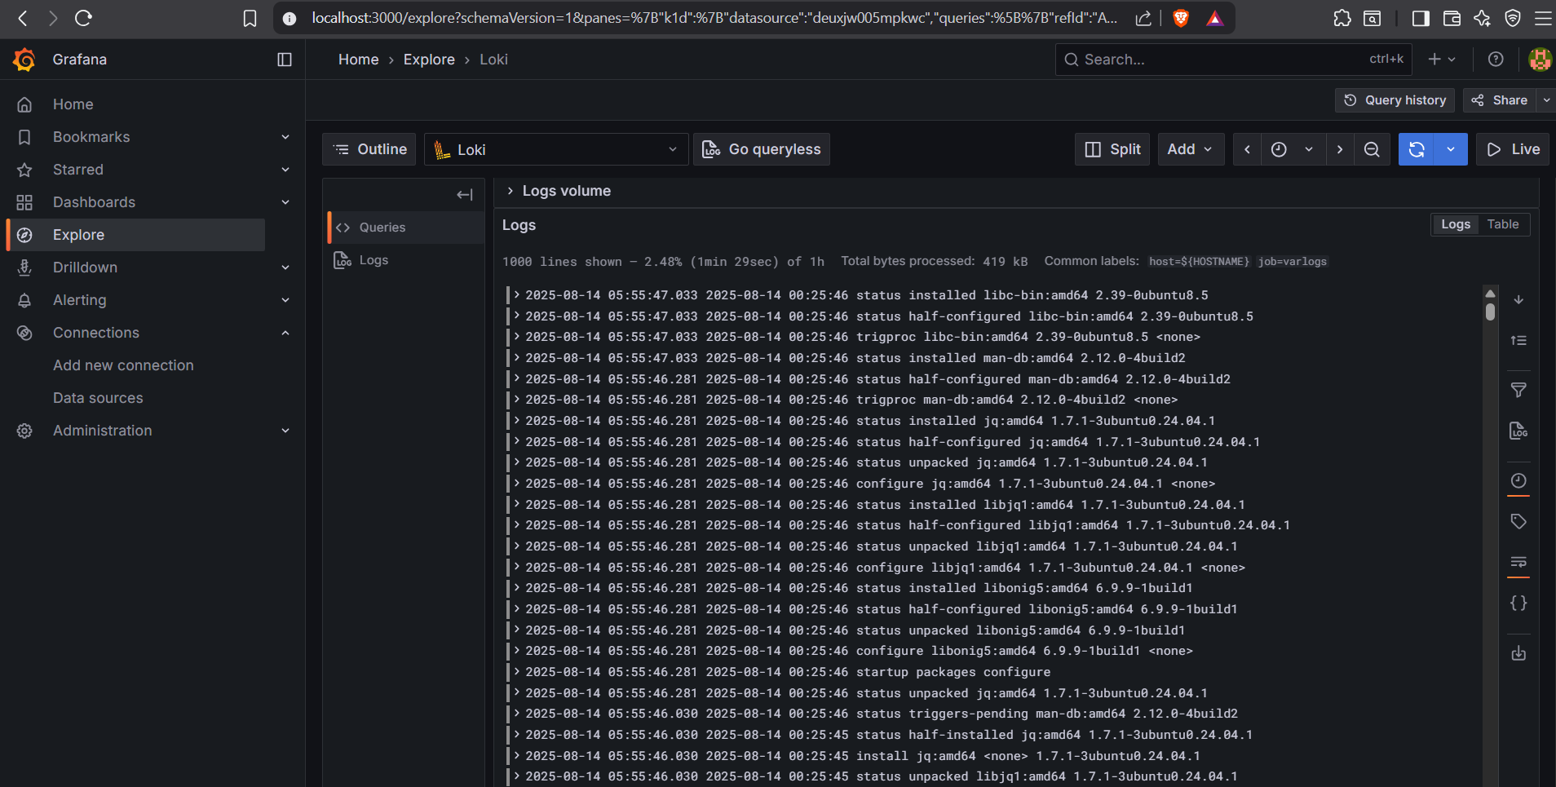

Step 4 Import Loki Dashboard

- Go to Dashboards Create dashboard

- Dashboards organize multiple visualizations (graphs, logs, tables) in a single view

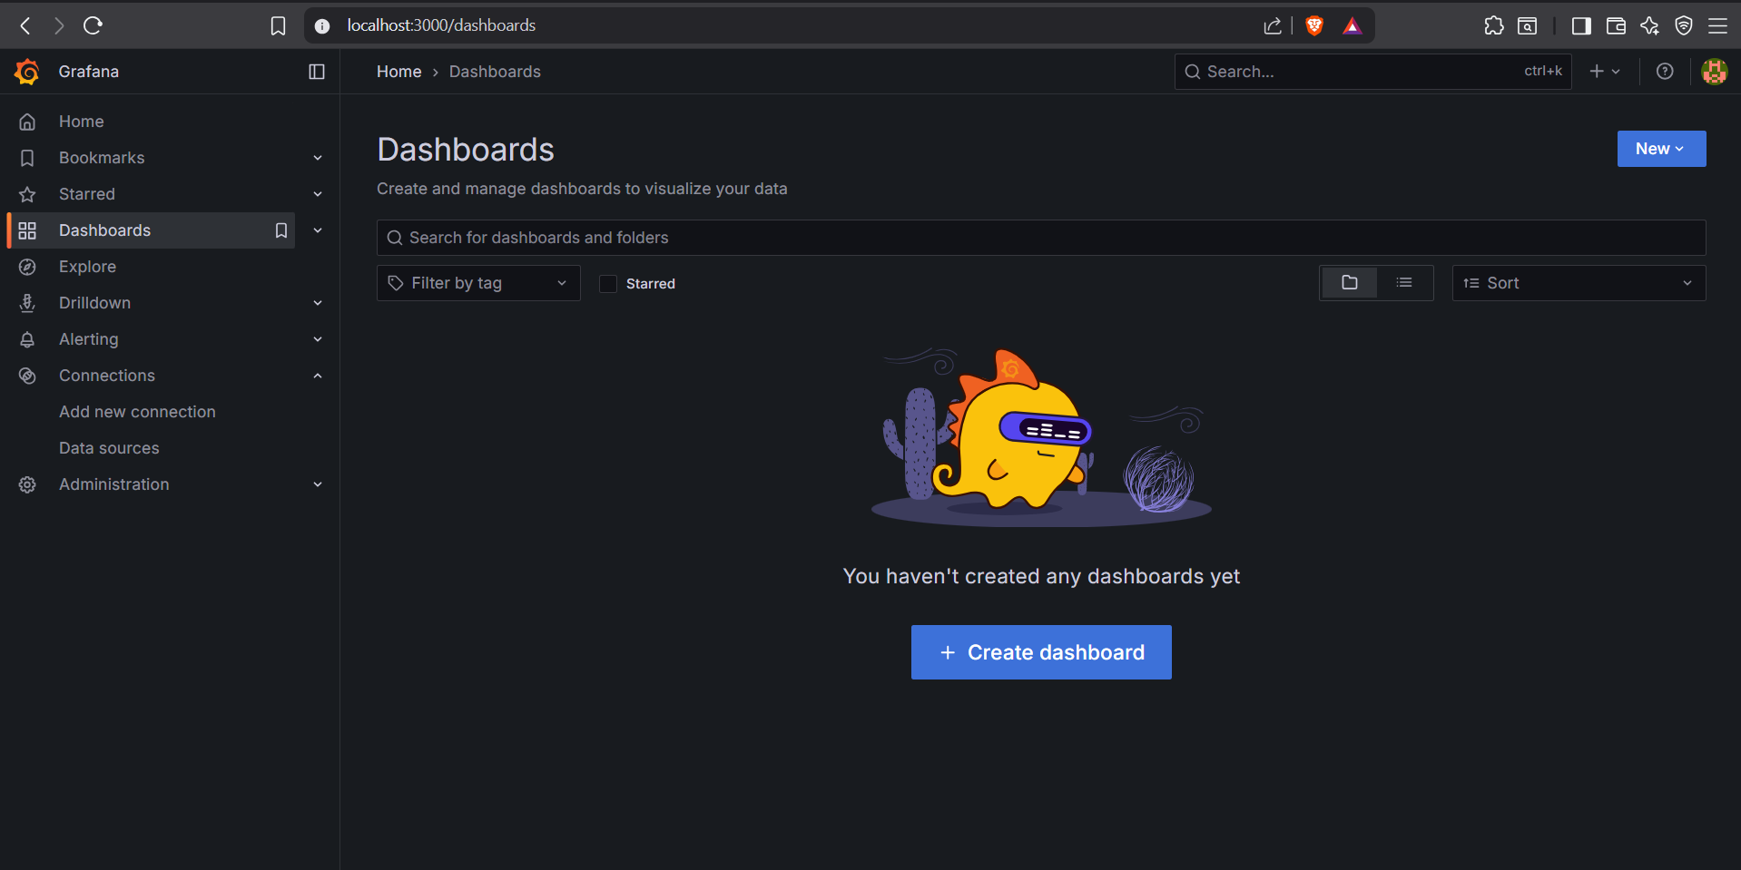

- Click Add visualization

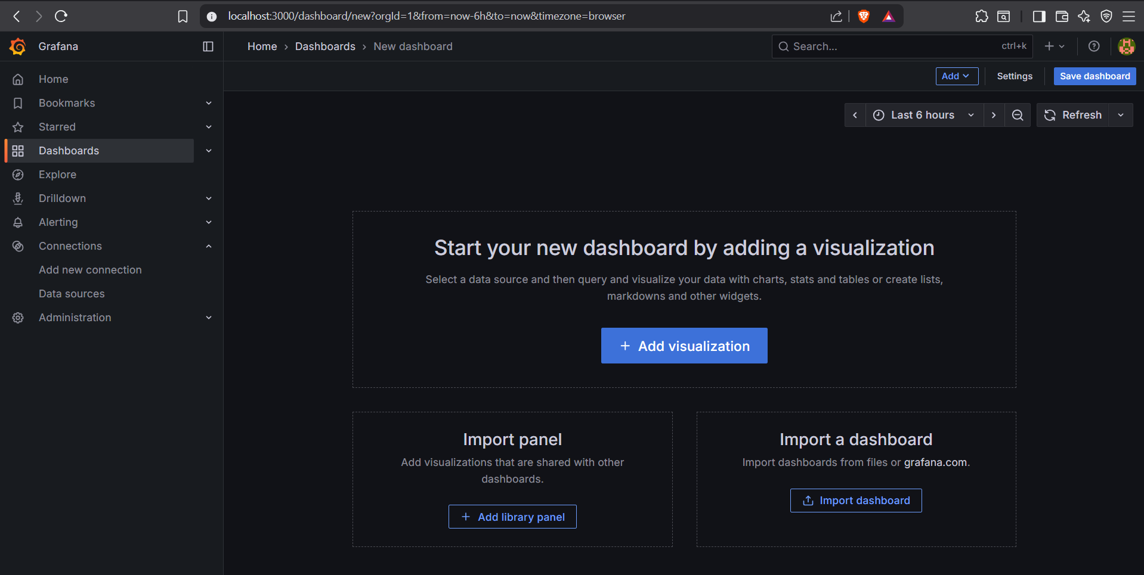

- Choose Loki as the data source for the visualization

- This ensures the query fetches logs from Loki

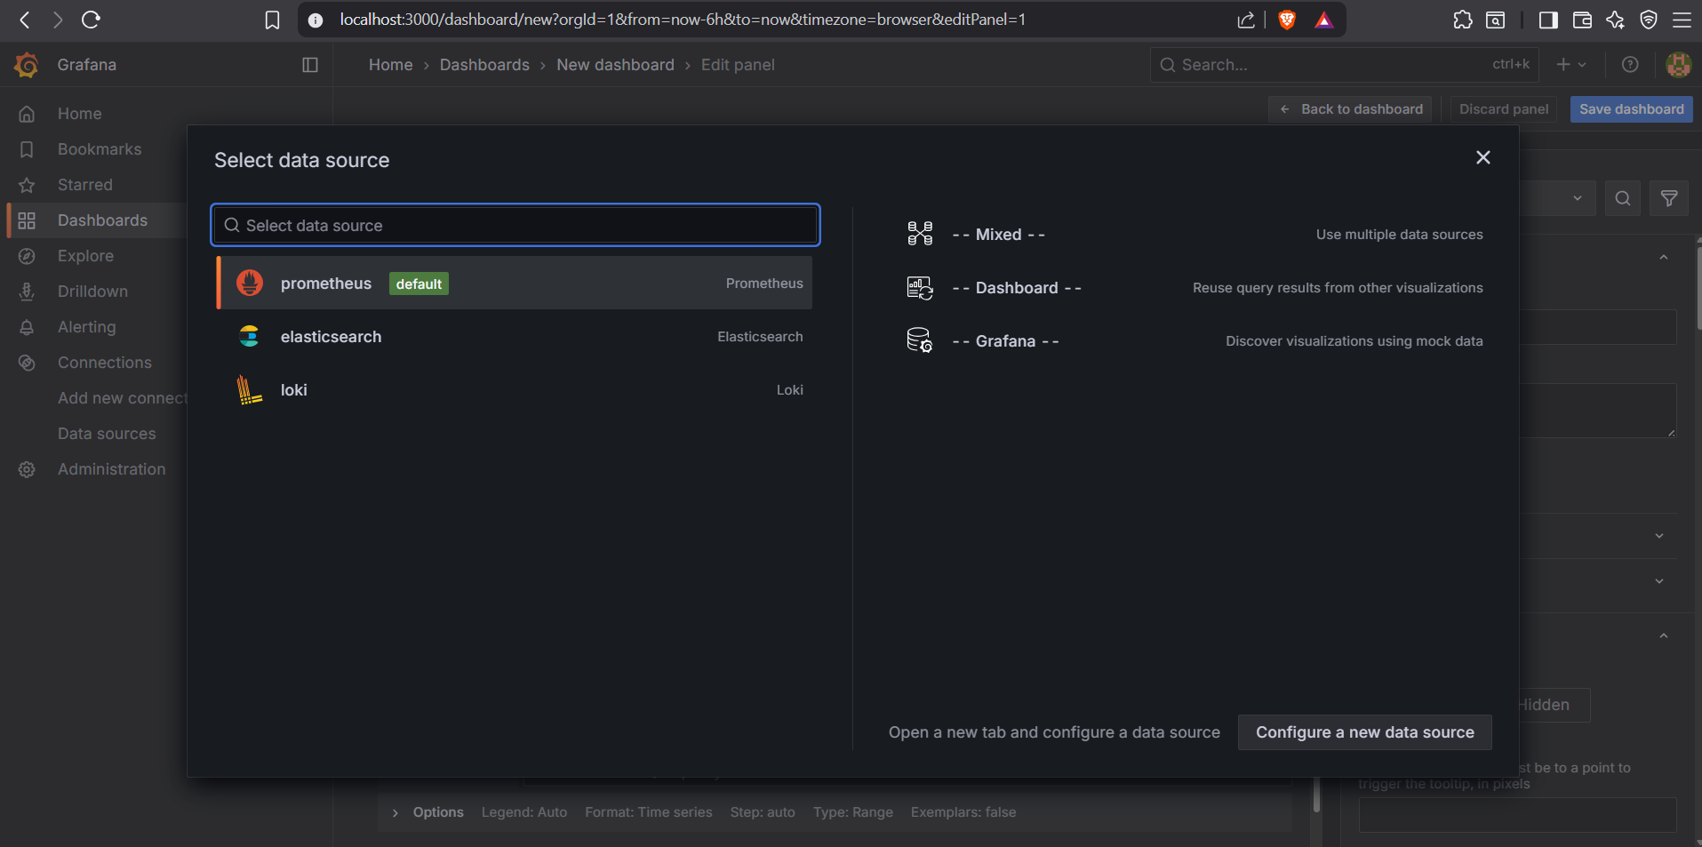

- Add Basic Log Query:
  - {job="varlogs"}

(Show all logs from a specific label (e.g., job="varlogs"))

- Click Run Query to load logs

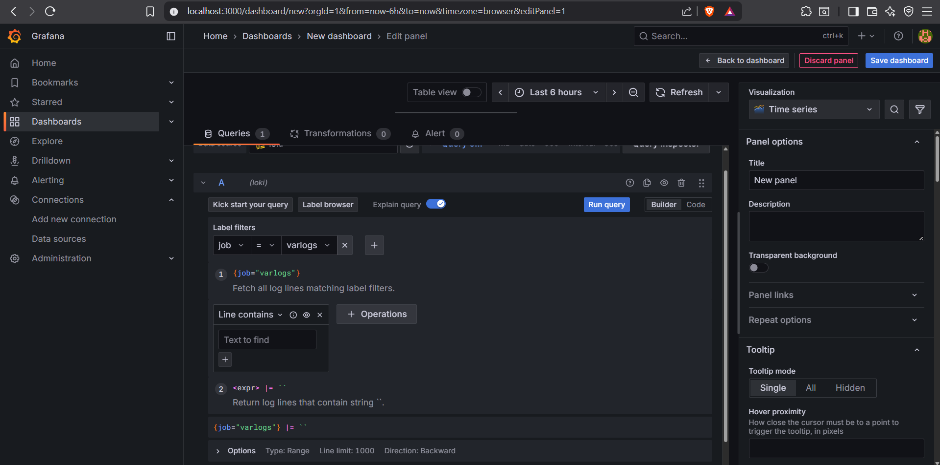

- Switch to the Visualization tab and select a preferred display format:
  - Time Series: Track log trends and frequency over time
  - Bar Chart: Compare log volumes across categories or time buckets
  - Timeline: Correlate events across multiple log streams
  - Choose based on analysis needs

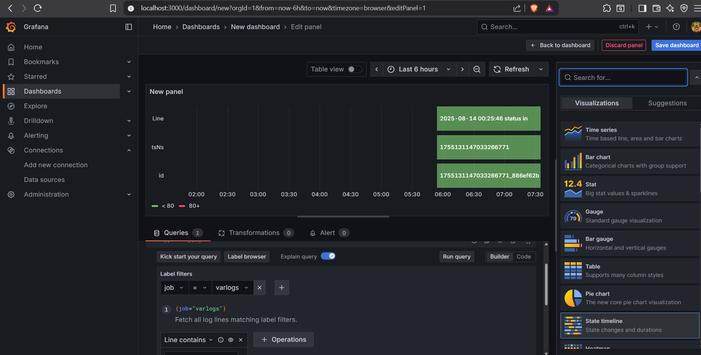

- Click Save to store the dashboard
  - Provide a meaningful name
  - Dashboards can be shared, exported, or reused

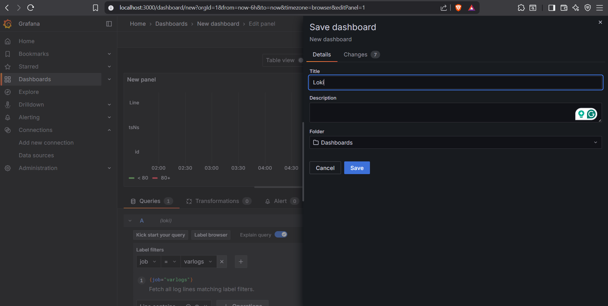
Conclusion

By following this guide, you have successfully set up a centralized logging environment on Ubuntu using Docker:
- Promtail collects logs from the system.
- Loki stores logs in a scalable and queryable format.
- Grafana provides visualization and exploration of logs.

This setup allows you to monitor logs from multiple sources in one place, making troubleshooting and analysis much faster. It’s ideal for development, testing, and small-scale production environments. You can extend this setup further with alerts, additional dashboards, and multiple servers to scale your centralized logging infrastructure.

